**Lab 9**

**Construct a NFA over {a, b} that accepts strings having aa as substring**

**Source Code:**

states = ['q0','q1','q2']

string = input("Enter the string ")

lstring = list(string)

stateSet = [states[0]]

previousStates = []

print(stateSet)

print("The sequence of states is:")

print(stateSet)

for i in range(len(string)):

previousStates.extend(stateSet)

stateSet = []

if (states[0] in previousStates and lstring[i] =='a'):

stateSet.append(states[1])

stateSet.append(states[0])

if (states[0] in previousStates and lstring[i] =='b'):

stateSet.append(states[0])

if (states[1] in previousStates and lstring[i] =='a'):

stateSet.append(states[2])

if (states[2] in previousStates and (lstring[i] =='a' or lstring[i]=='b')):

stateSet.append(states[2])

print(stateSet)

previousStates = []

if (states[2] in stateSet):

print("The string has been accepted")

else:

print("The string has not been accepted")

**Output:**

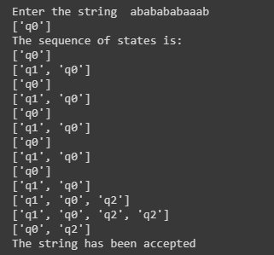

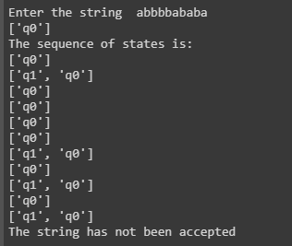

**Conclusion:**

Thus, program to construct a NFA over {a, b} that accepts strings having aa as substring